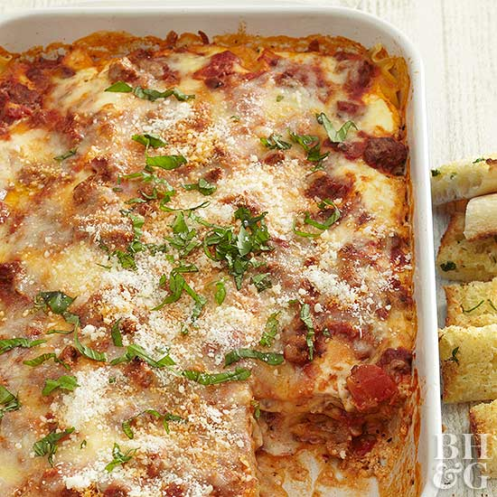
Better Homes & Gardens Lasagna (1953 Classic)
Prep time 1 hr 10 min Cook time 30 min Rest time 15 min
12 Servings
Ingredients
For the sauce
1 lb bulk Italian sausage
1 large clove garlic, minced
1 tbsp dried basil leaf, crushed
(2) 15 oz cans diced tomatoes, undrained
(2) 6 oz cans tomato paste
For the rest
12 lasagna noodles (10 ounces)
3 cups fresh Ricotta
½ cup grated Parmesan or Romano cheese
¼ cup snipped fresh parsley
2 beaten eggs
½ tsp salt
½ tsp freshly ground black pepper
1 lb shredded Mozzarella cheese
Directions
- Brown the meat in large skillet with lid; drain excess fat. Add the next 5 ingredients. Simmer, covered, 30 minutes, stirring occasionally.
- Beat the eggs and combine with remaining ingredients, except the Mozzarella cheese.
- Spread a small amount of meat sauce to lightly cover bottom of silver lasagna pan. Place half the noodles in the pan; spread with half the ricotta filling; add half the Mozzarella cheese and half the meat sauce. Repeat the layers. Save some mozzarella cheese to sprinkle on top.
- Bake, uncovered, in a 375 degrees oven about 30 minutes or until thoroughly heated through. Let stand 15 minutes before cutting into squares (filling will firm up slightly).
Notes
You can assemble as directed ahead of time. Cover and refrigerate up to 24 hours. Add about 15 minutes more to the bake time.

